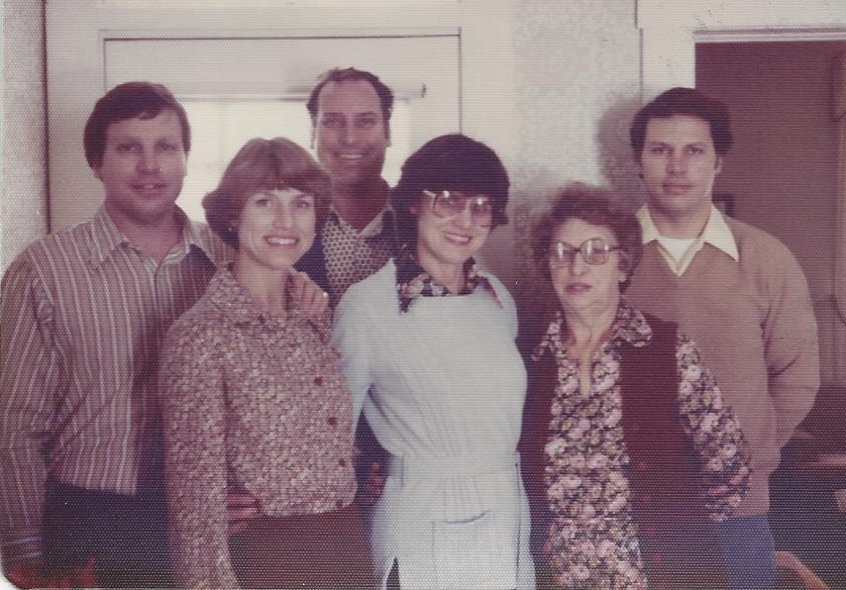

Nelson, Mary Jo, Phil, Lois, Mary, John - Feb 1979



Nelson, Margaret, Mary Jo, John - 30 July 2004